Databases
Need reliable and flexible data storage everywhere.
Could use text files, but cannot do structured queries. There is no unified and central means of accessing and controlling the data, and data structure can only be defined implicitly.
In a database, data is logically related, the structure of the database is self-describing and there is some form of data abstraction.

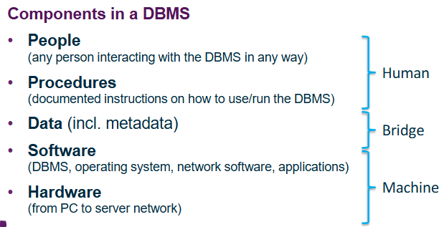
Database Management System (DBMS):
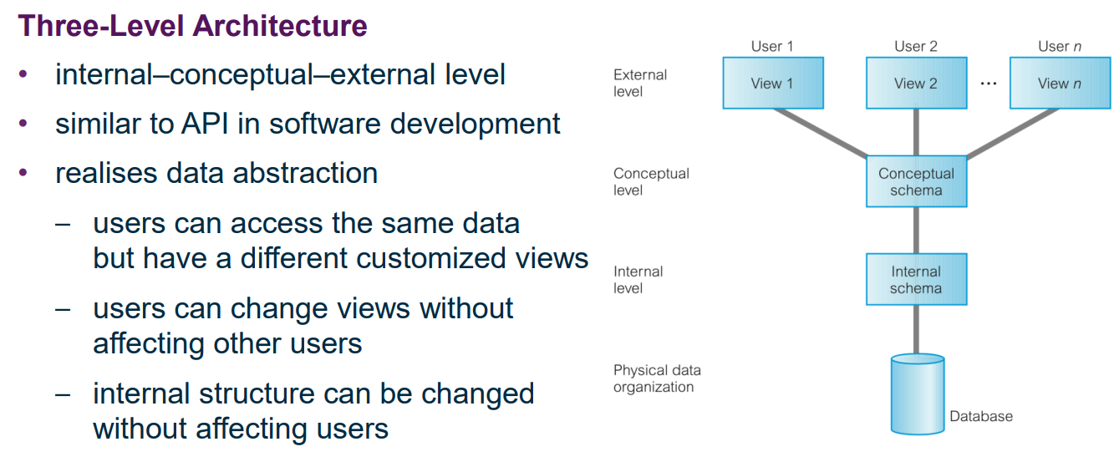
A DBMS is a software system to define, maintain, create and control access to a DB.

Roles in a database environment:
- End users – naïve (view data) and sophisticated (can make queries)
- Application developers – need to make use of DB for a specific purpose
- Database designers (logical and physical)
- Administrators – data and database administrators.
Advantages and Disadvantages of DBMS:
- Control over data redundancy, consistency, standards
- Improved accessibility and productivity
- Improved maintenance, security, backup/recovery, scaling
- High complexity, size and cost
- Single point of failure
- Performance
Overview:
Relational Data Model
- Relation = table with columns and rows (file)
- Attribute = named column (field)
- Tuple = row [record]
- Relational DB = collection of normalised relations

Entity Relationship Modelling
- Non-technical model for communication
- Not ambiguous
- Unified modelling language (UML)
- Entities with attributes, relationships between entities and constraints on entities, attributes and relationships.
- Top down approach to database design.
Normalisation
- Purpose – identify a set of relations with desirable properties for the given use case, minimal no of attributes, minimal redundancy
- Attributes with close logical relationship
- Bottom up technique, validation of top down design
- 1st, 2nd and 3rd normal forms
SQL
- Data definition, data manipulation and data queries.
Relational Calculus (uh oh) and Relational Algebra
- Mathematical backbone of SQL
- Unary and Binary operations

Three level ANSI-SPARC Architecture
- Internal, conceptual and external levels
- Similar to API in software development
- Data abstraction – different users can have different views of the same database, i.e. can access and see different data
External Level
- User’s view of the DB
- Different entities, attributes, relationships etc based on user privileges; multiple views of the same data based on preferences (e.g. units, date format)
- Possibly derived or calculated, e.g. age derived from date of birth as DoB is constant but age changes over time.
Conceptual level
- Community view of the DB; shared by all users.
- Describes exactly what data is stored – entities, attributes, relationships, constraints, security
- Logical structure of entire DB, not just what one user sees
- Must support external views
- No specific details on how the data is to be stored, or how the hardware is used / organised to store the data.
Internal Level
- Physical representation of DB
- Describes how data is stored
- Includes what compression and encryption used
- Interface to OS
- Optimisations for performance and storage space utilisation.
- Not clearly separate from physical organisation
- (mostly handled by general purpose software such as mySQL)

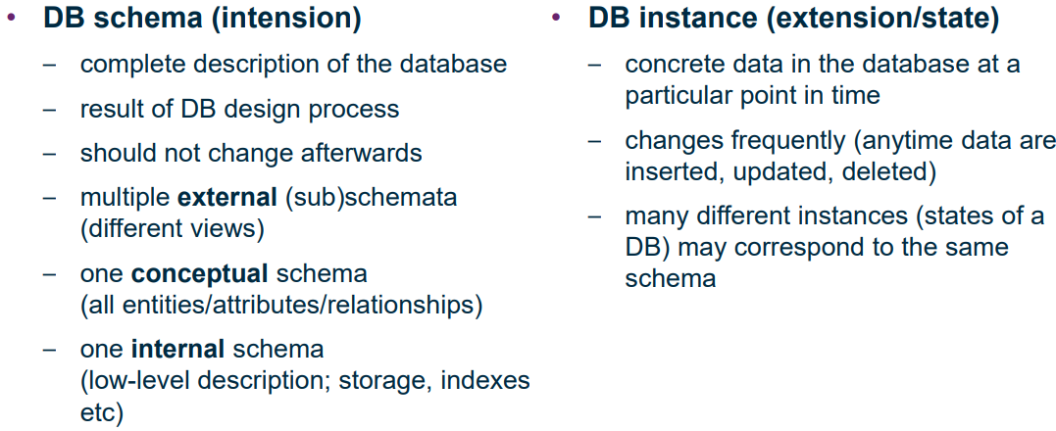
Schema vs Instance:
Schema does not include actual data, it is just the abstract structure of the DB. Instances involve having specific data inside.
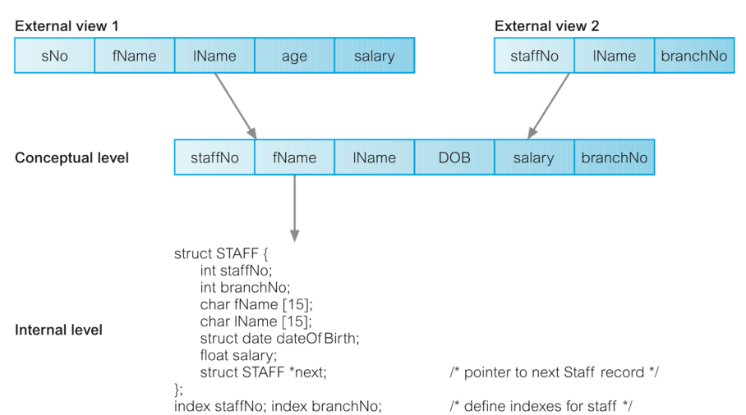
Example of levels:
Data Independence
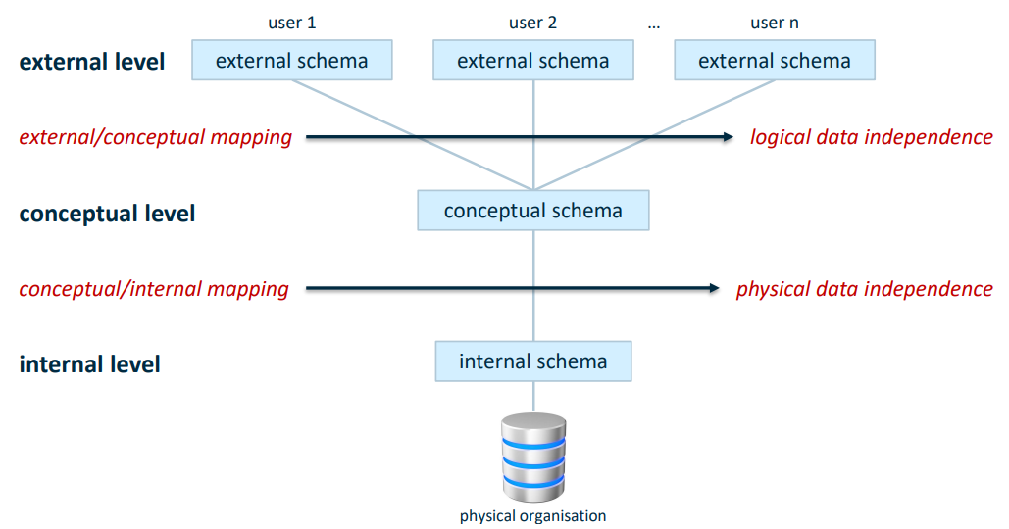
Logical data independence: external views remain the same if we change the logical structure (i.e. the schema) on the conceptual level
Physical data independence: conceptual schema remains the same if we change the internal schema (data structures, algorithms, …)

Phases of Database Design
- Conceptual -> constructing high level models of the data using ER modelling, identifying entities and relationships etc based on the user’s requirements. Serves as the fundamental understanding, rather than focussing on implementation or physical considerations.

- Logical -> Construction of the relational data model for the data, i.e. mapping entities and relationships to tables and using normalisation to eliminate redundancies in the data.

- Physical -> Describing the implementation of the logical design, defining specific storage structures, access methods and security. Considering implementation details (encryption compression etc) and optimisations.

Relational Data Model
Data Definition Language is too low level. We need a more abstract, mathematically sound model to describe data structure.
The Relational Data Model is based on the concept of mathematical relations. Relations are stored in tables. It is the most widely used model for structured data.

The schema of a relation R: R(A₁,A₂, … , A_{n})
- Attributes A₁, etc
- E.g. Student(studentNo, prename, surname)
- Ordering of attributes does not matter (as long as the order is consistent) – we use their names. This is different to mathematical relations.
- All data in a database is stored in relations (tables)
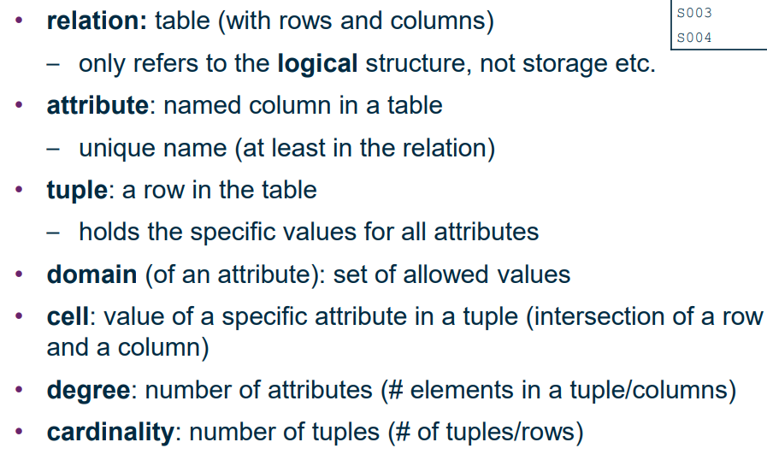
Definitions:

A relation is normalised if it is appropriately structured:
- Fulfils certain conditions
- Every cell contains exactly one value
- No repetition of identical tuples
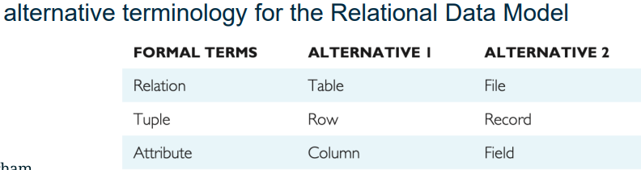
A relational database is a collection of normalised relations, each with a unique name.

Domain of an attribute:
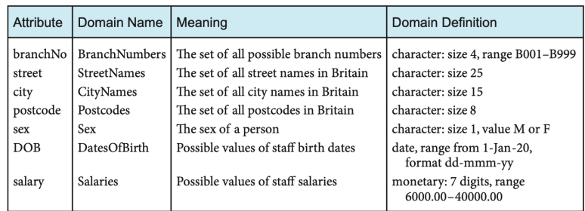
Every attribute is defined on a domain – a definition of the meaning and allowed values for an attribute. This allows semantically incorrect operations to be avoided. E.g:
Null value:
NULL indicates the absence of a value – either a value that is currently unknown or not applicable. NULL is not a normal value (i.e. not the same as False, 0 or “”) and has to be handled in a special way. NULL can cause implementation problems -> what is 1 + NULL ?
Keys:
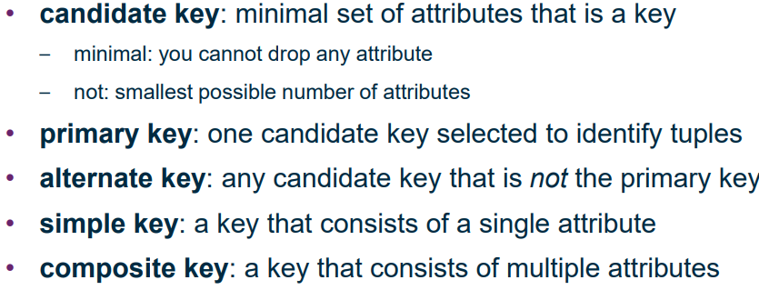
Key: a set of attributes whose values uniquely determine a tuple. Allows for uniquely identifying tuples within a relation.
Foreign keys – used to reference another entity. Must either match the primary key of another table or be null.

Integrity Constraints:
Domain constraints – attribute values must always lie within their respective domain
Entity integrity – Primary key attributes cannot be NULL -> guarantees each row has a unique identifier and ensures foreign keys form proper references
Referential integrity – Foreign keys must either match some primary key or NULL to ensure references are valid. Deletions of tuples are prevented if referenced somewhere else (the reference also needs to be deleted or set to NULL).

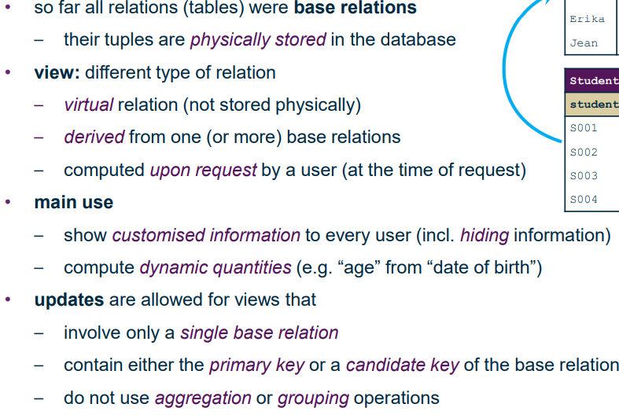
Views:

RDM alternatives: Network Data Model and Hierarchal Data Model (not relevant to course).

Entity Relationship Modelling
(not the same as Relational Data Model)
- Conceptual db design for communication – non-technical and free of ambiguity
- Unified Modelling Language (UML)
- Entities with attributes
- Relationships between entities
- Constraints
- Top-down approach

Entity Relationship Model vs Relational Data Model

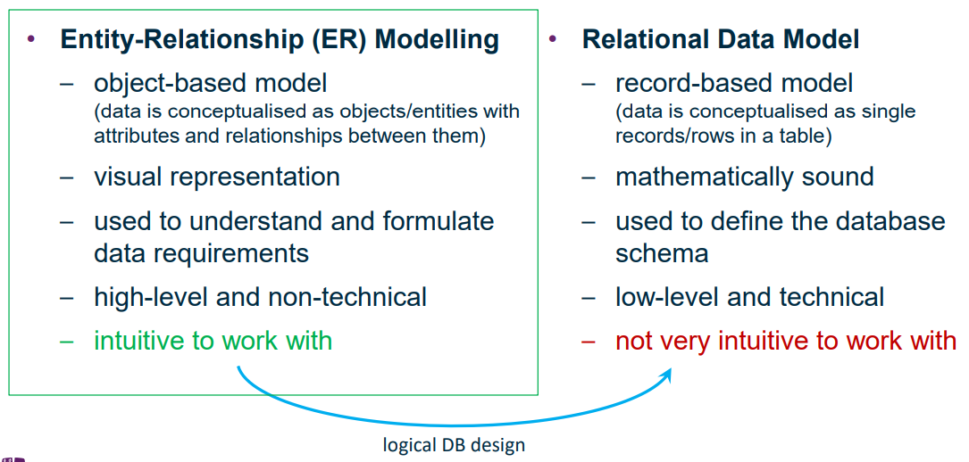
Top-down:
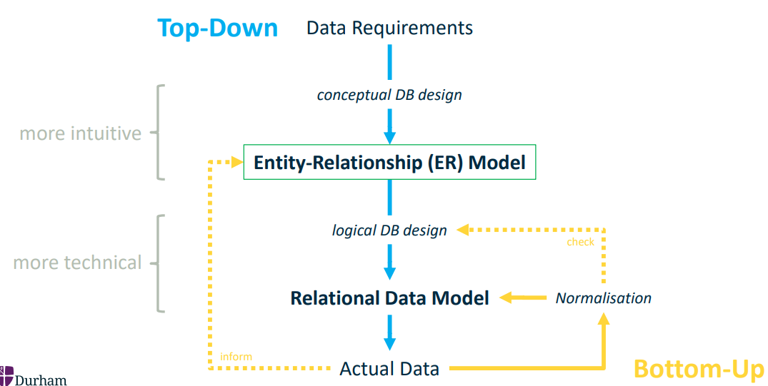
a
Entities
Entities are “things” that should be explicitly represented
Visual representation = labelled rectangle
Entity type – class of all objects with the same properties, e.g. the concept of a “student”
Entity occurrence – a concrete instance of a type, e.g. “John Smith”
Relationship
Relationships are named associations between 2 entity types
Visual representation = labelled line
Relationships have constraints on the number of entity occurrences that can participate in a relationship
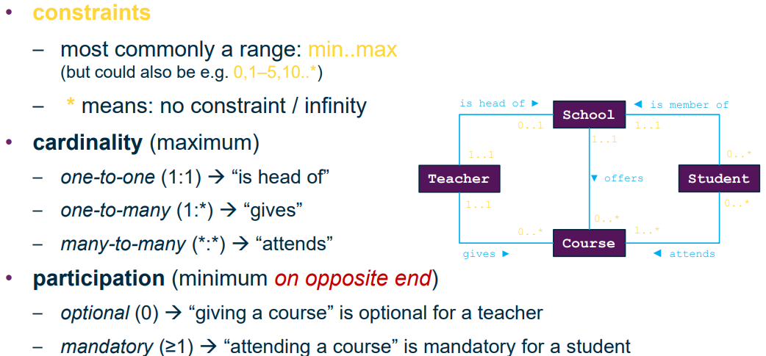
^ e.g. a course can only be taught by exactly 1 teacher, but a teacher can teach 0 or more courses.
Attributes
Attributes are properties of an entity type
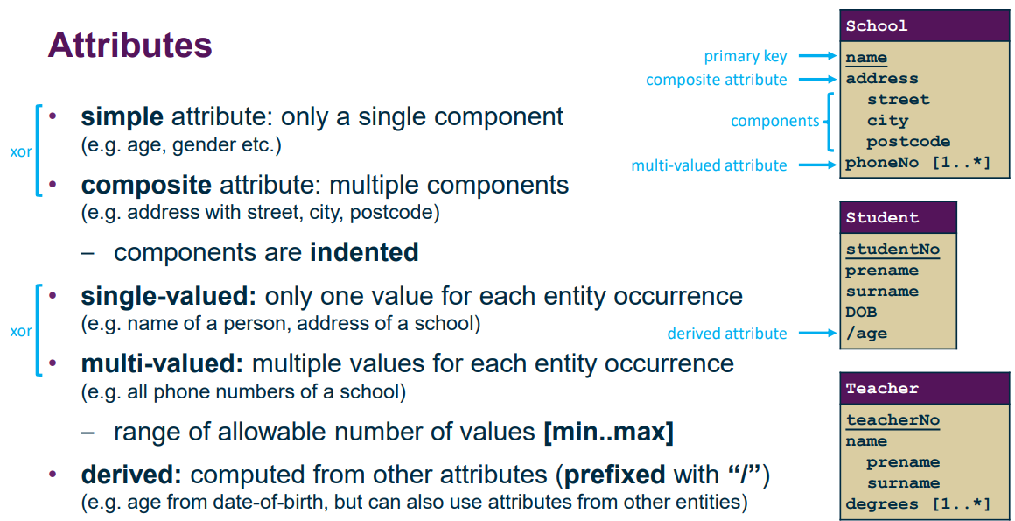
Visual representation = attributes listed in lower part of entity rectangle, names in camelCase and primary key underlined.
Transforming to Relational Data Model
- There is not always a direct correspondence between entities and tables
- Foreign keys need to be used to represent relationships:
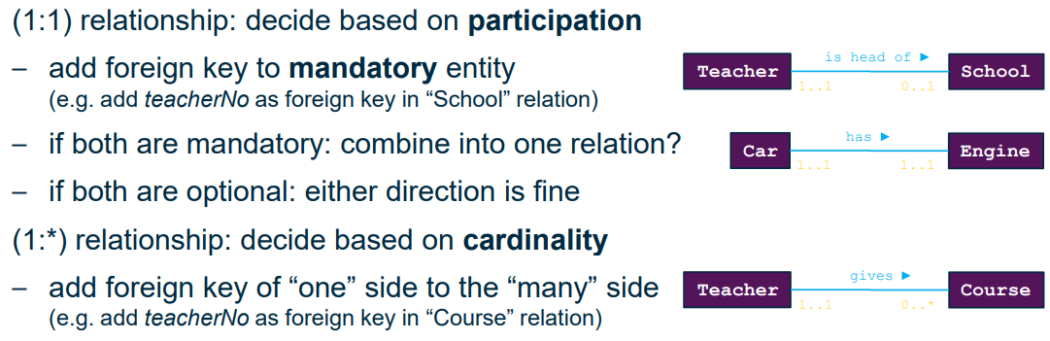
^ e.g. instead of putting schoolID in Teacher table to represent teachers being a head of school, headTeacherID should go in the School table. This is because not every teacher can be head of a school, and so if a teacher is not head of a school, a foreign key in this teacher’s record in the Teacher table would not contain a valid reference.
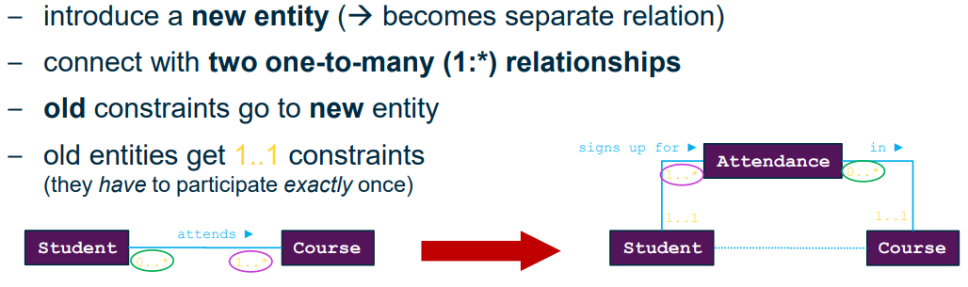
For many-many references, we have to create a separate relation with two foreign keys:
^left constraint on old relationship goes to right side of new table and vice versa; new relationships are 1..1
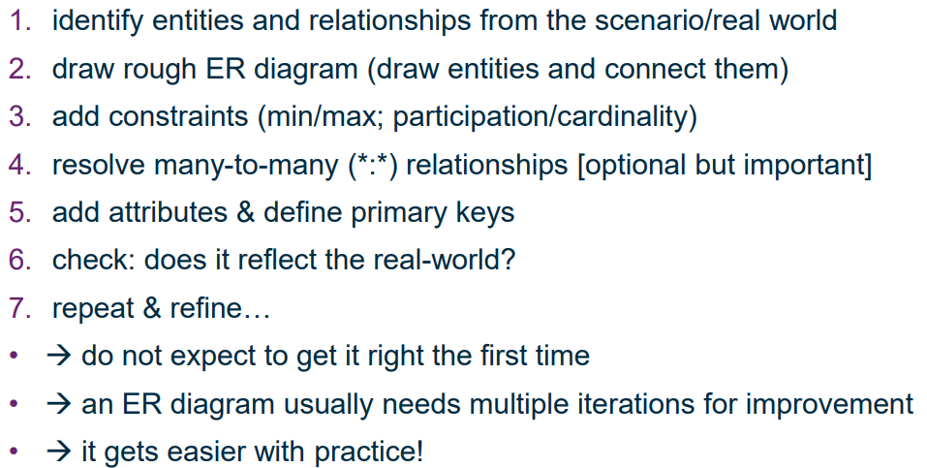
To construct an E-R model:

Normalisation – used in bottom up approach, where relationships between attributes are analysed and the tables are redesigned in a better way.
By this we mean minimising required space and avoiding data anomalies, and by elimination redundancies which are wasteful in storage space and can lead to inconsistency in the data. Data should not be duplicated.
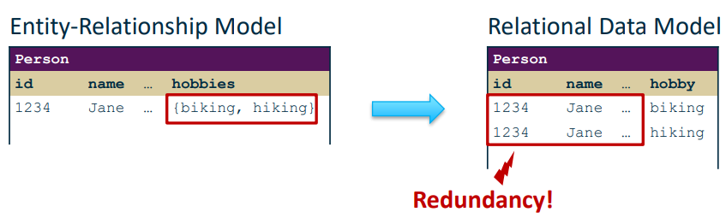
Example: multi-valued attributes
Example 2: Dependencies between attributes
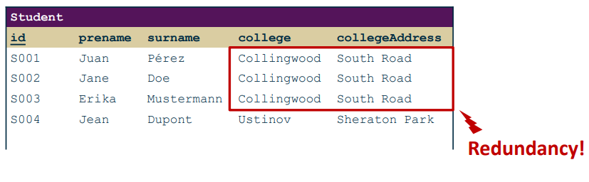
^College address is the same for all students of the same college -> the collegeAddress attribute is dependent on the college attribute, not the student.

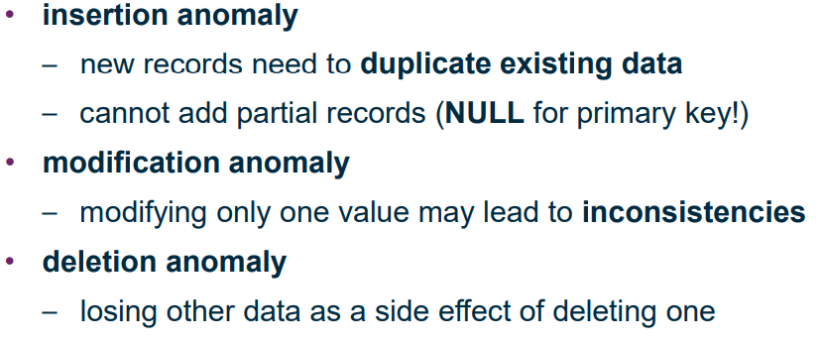
Anomalies:
These can be avoided by decomposing tables so every attribute of a table is dependent on that table’s primary key, e.g. have a separate table for Student and College, with the collegeAddress in the College table, with a foreign key in Student linking to College.
Functional Dependencies:
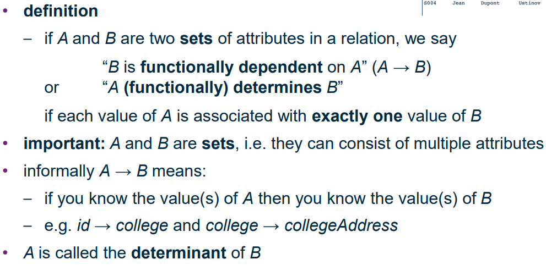
Functional dependencies describe the relationship among different attributes in the same table. They affect data anomalies and are the basis for normalisation. They are used to determine primary and foreign keys, as well as where to decompose the tables.
Note: both A and B can be sets of attributes that are functionally dependent of each other, not just single attributes.
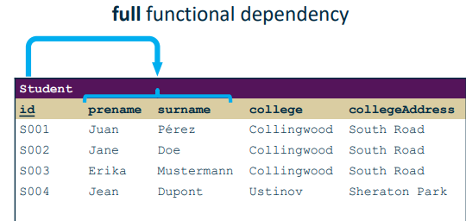
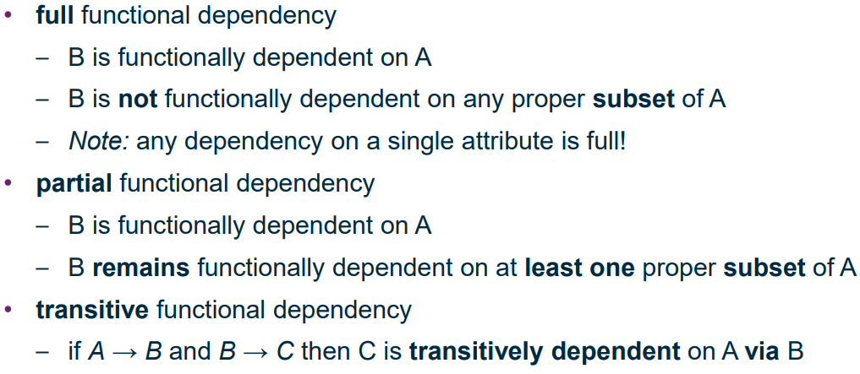
Examples:
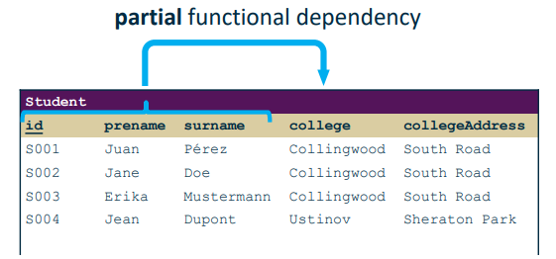

CollegeAddress is a transitive functional dependency on id via College. We do not want transitive dependencies within a single table.

How can we determine all functional dependencies?
- Some obvious
- Some follow from specification
Given a set of functional dependencies F, its closure F⁺ are all functional dependencies implied by the dependencies in F. We need a set of rules to determine F⁺
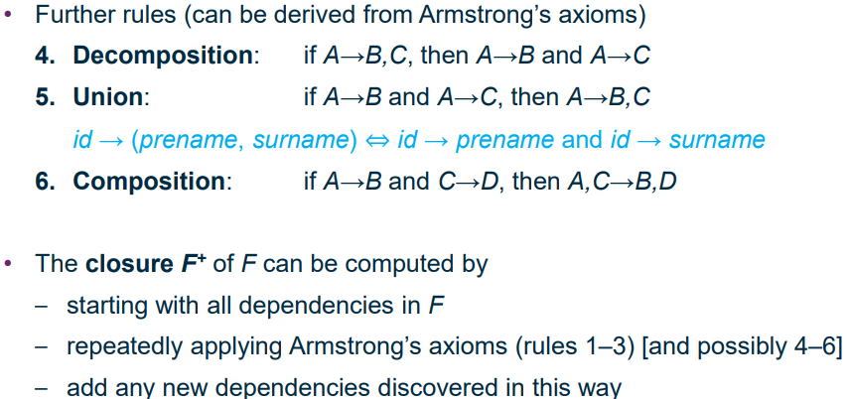
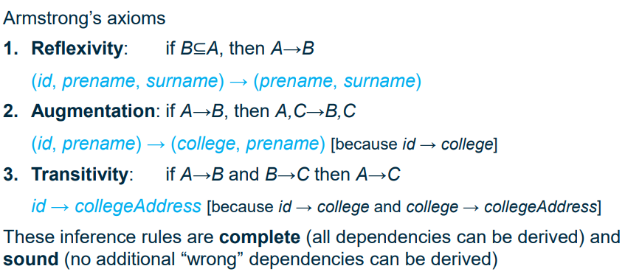
(can we like not turn databases into math???)
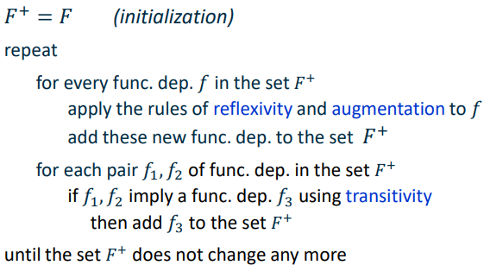
F⁺ computation “pseudocode”:

Normalisation
1st Normal Form – a table is in 1NF if it has no repeating groups, i.e. every cell has one value. A repeating group is an attribute or group of attributes with multiple values for a single occurrence of the primary key.
Repeating group example:
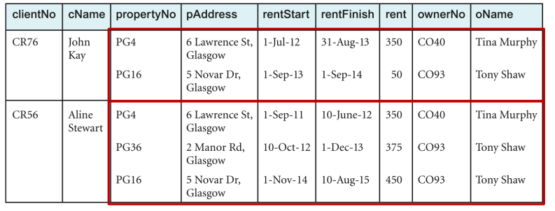
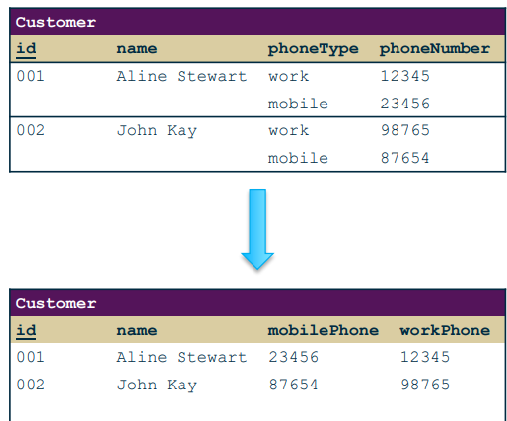
If there is a fixed number of repetitions, then we can use separate attributes for the repetitions:

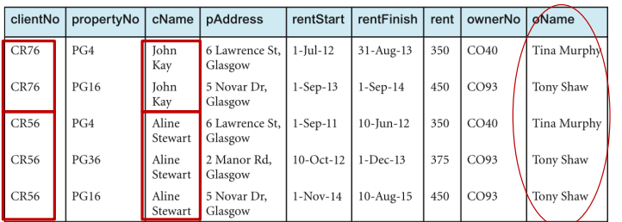
Otherwise we can flatten:
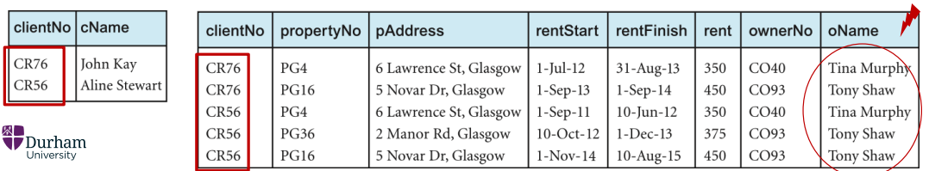
Or can create a separate relation, linked with foreign keys:
But we still have redundancy (circled).

Second Normal Form – A table is in 2NF if it is in 1NF and every non-key attribute is fully functionally dependent on the whole primary key -> no partial functional dependencies. Only relevant for relations with composite keys.
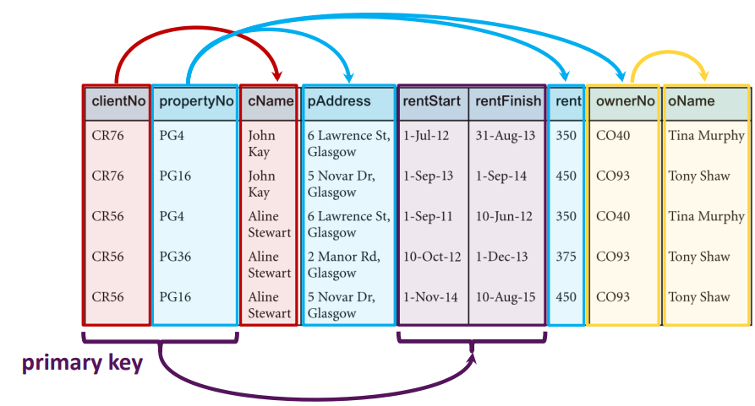
^only rentStart and rentFinish are fully functionally dependent on the primary key ( which is the composite of clientNo, propertyNo)
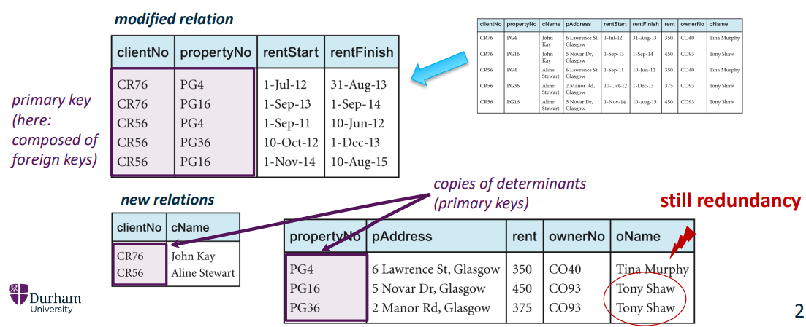
To fix this we need to remove the partially dependent attributes and place them in a new relation along with a copy of the key attribute that they are fully dependent on.
But we still have redundancy as a result of the transitive dependency of oName -> ownerNo -> propertyNo.

Third Normal Form – A table is in 3NF if it is in 2NF and has no transitive functional dependencies.
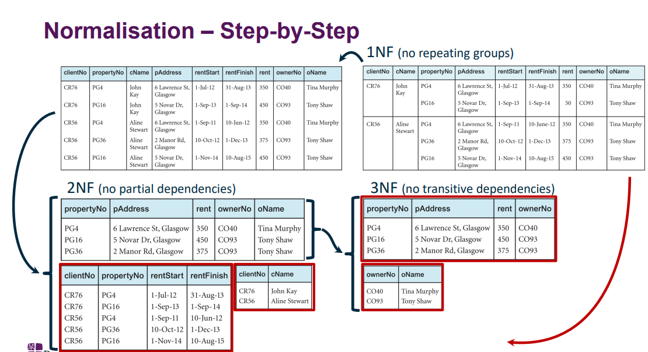
To fix this, we remove the transitively dependent attributes and place them in a new relation with the primary key as their determinant.
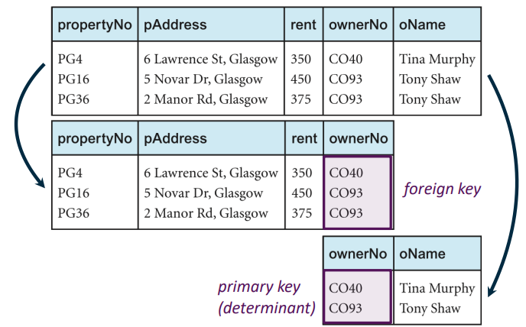

(there are more NFs but we don’t care about them )

SQL
A good database language should allow users to create a database (define relations, attributes, constraints etc), perform basic data management operations (insertion, updating, deletion), and perform simple and complex queries. It should also be easy to learn and use, and meet a recognised standard so it can be portable across different DBMS.
SQL – Structured Query Language
- Most common
- Simple syntax
- Two components: DDL and DML
DDL – Data Definition Language – defines the schema for each relation, defines the domain of each attribute and the constraints, keys etc.
DML – Data Manipulation Language – Insert, update, delete and retrieve data. Query Language = the part of the DML involving retrieval.

SQL is declarative, i.e. specifies what data is to be retrieved rather than specifically how to retrieve the data (procedural). Internally, SQL is transformed to procedural form before being executed but this is abstracted.
SQL statements consist of:
- Reserved words, e.g. SELECT, WHERE, operators etc
- User-defined words, e.g. relation/attribute names
- Literals – strings in ‘single quotes’, numbers not in quotes.
Most components are case-insensitive, except for table names and string literals. White space and indentation do not matter. Statements can be chained and terminated with a semicolon.
Main statements of interest in DML: SELECT, INSERT, UPDATE, DELETE

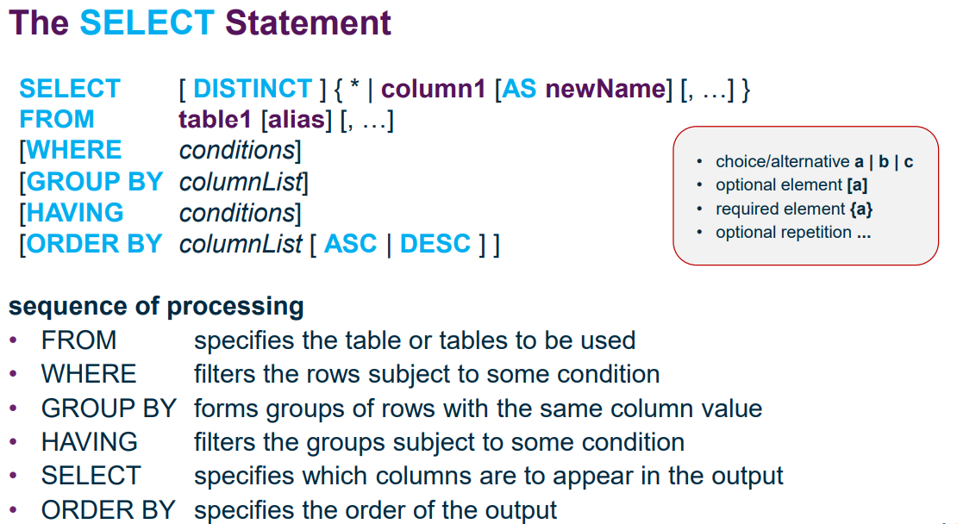
SELECT statement:
Note: * is a special character meaning “all columns”, e.g. SELECT * FROM tableName will retrieve all fields of the records returned by the query.

We can also use functions in the SELECT statement to derive attributes, and use the AS clause to assign it a different name:
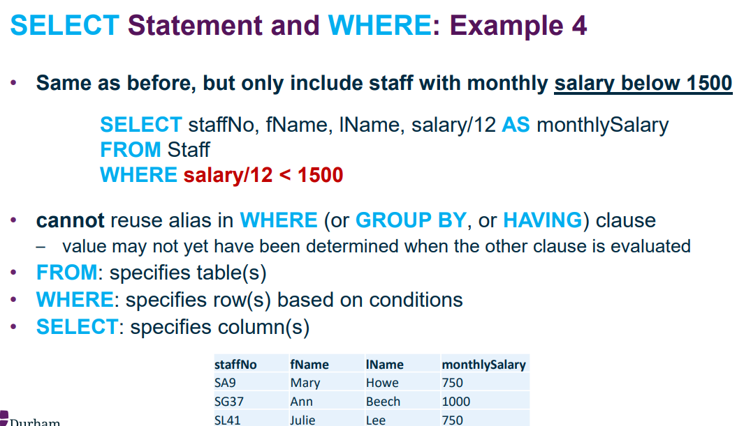
^salary/12 is a derived attribute and in the resulting data it is assigned the name monthlySalary by the AS clause
We cannot use the aliases created in the SELECT statement in the WHERE clause as in reality, the WHERE clause is processed before the SELECT clause and so the alias would not have been defined.

SELECT DISTINCT prevents repeated results from being returned multiple times, e.g. selecting Gender from a table of people will return M/F etc for each person in the table; select distinct will just return each gender once.
Conditions:
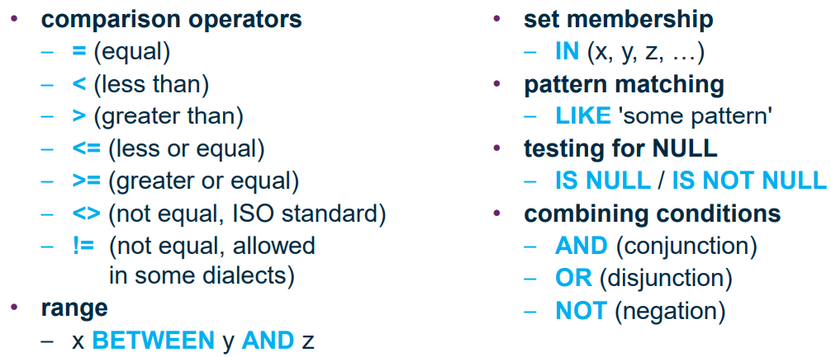
^ note: BETWEEN is inclusive -> if x == y or x == z it will return these too. Could just use comparison operators instead.
IN is also pretty useless, could have WHERE attribute == x OR attribute == y OR …
LIKE can be used for pattern matching. Wildcards:
- % - represents an arbitrary sequence of 0 or more characters
- _ - represents a single arbitrary character.
E.g. LIKE ‘H_ _ _’ returns any strings of 4 characters where the first character is H
NOT LIKE ‘A%’ returns any strings where the first character is not A.
LIKE ‘H_%E’ returns any strings beginning with H, ending with E and with at least 1 character in between.
Note: single quotes for strings

Use parentheses to group expressions to make it safer and more readable – there is an order of operations and it will probably bollocks up your query if you don’t.

To test for NULL, use IS NULL or IS NOT NULL -> null is not a value so cannot use comparison operators for this. Empty strings are not equivalent to null.

ORDER BY is used to sort the rows by a set of columns, either by ascending (default) or descending order.
E.g. ORDER BY gender ASC, fName DESC will sort first by gender and then sort each gender by first name descending.
Can sort by an attribute even if it is not returned in the SELECT statement.

SELECT aggregate functions:
^COUNT requires an attribute to count. COUNT(*) does not.

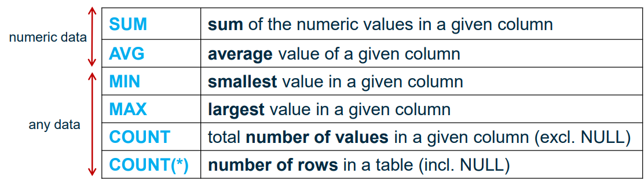
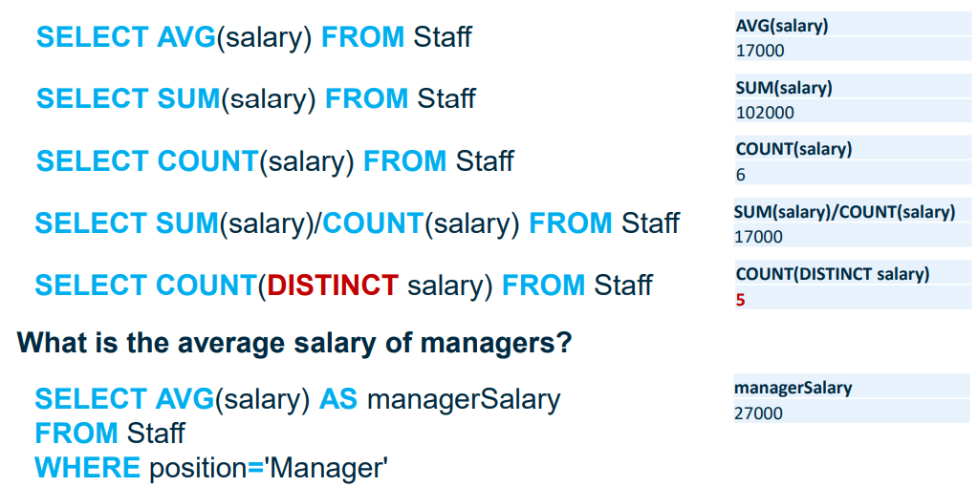
Examples:

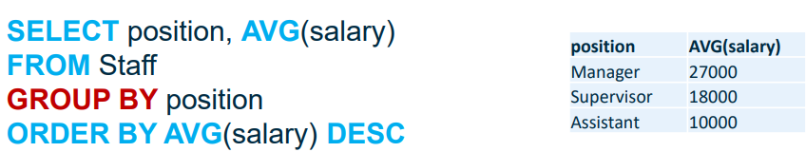
GROUP BY: used in combination with aggregate functions to first group rows by one or more attributes, then apply aggregate functions to each group separately.
(when using aggregate functions and group bys, make sure the table dimensions are consistent. If group by not used in above query, position column will have 3 records whereas AVG(salary) would have 1 record, and so this query would not form a valid table)

Joins – querying multiple tables:
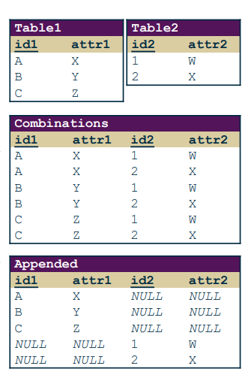
We need a way of querying multiple tables and combining into a single result. We usually want some combination of combining rows, filtering rows based on criteria and appending rows.
<- combining vs appending rows

Join types:

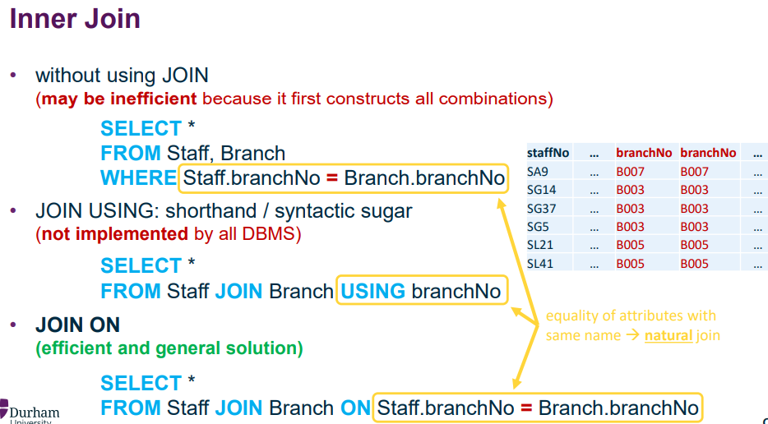
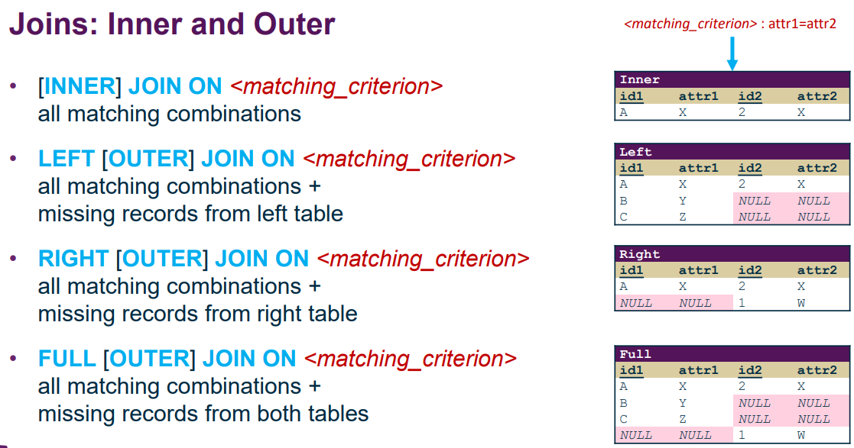
Inner join syntax:
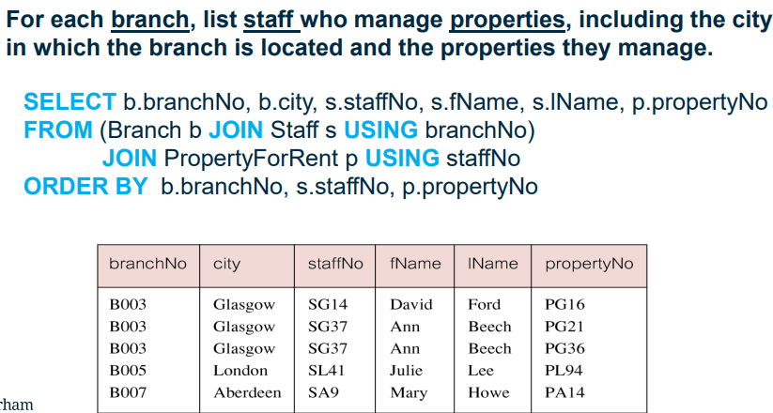
Example:
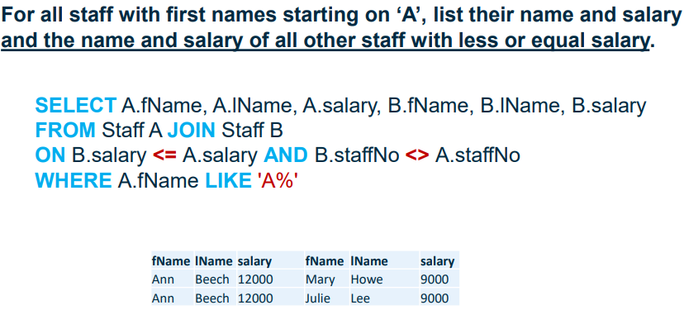
You can also join a table to itself:
^ since we are joining a table with itself we have to give aliases to each “copy” of the table -> A and B both reference copies of the Staff table.

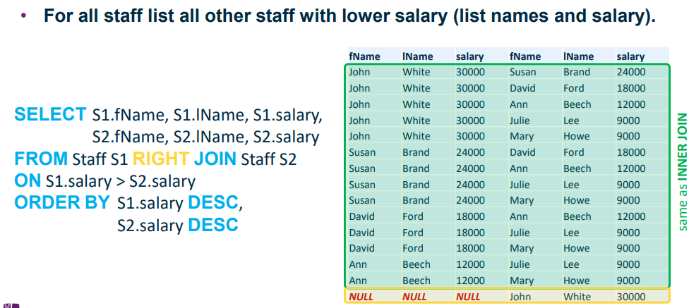
Outer join example – left vs right:
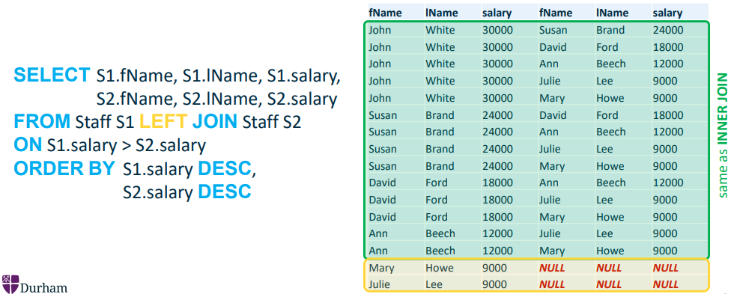

Subqueries: You can nest SELECT statements inside each other
- Single value subqueries are subqueries that return a single attribute for a single row
- Multi value subqueries return a single attribute for multiple rows
- Tabular subqueries return multiple columns and multiple rows
The type of subquery has to be taken into account when subqueries are to be used.
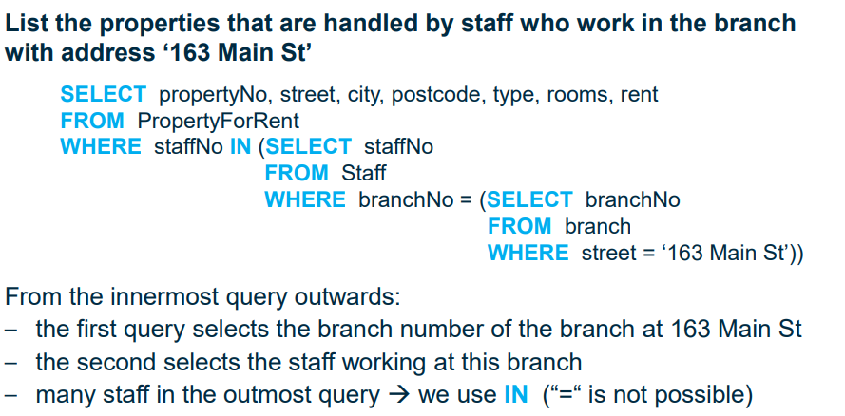
Examples:
^We can only use = for single valued subqueries; for multi value subqueries need IN to check whether staffNo is in the column returned by the multi value subquery.
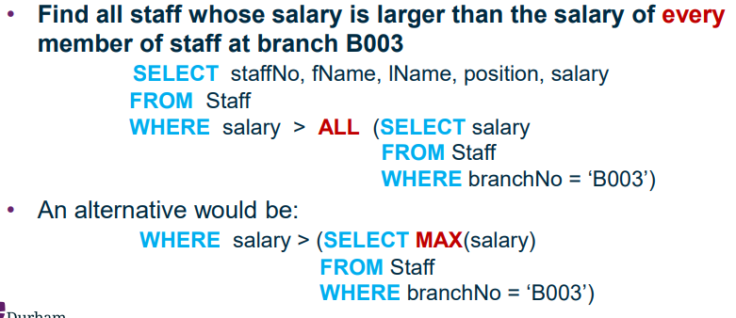
Multi-valued subqueries also allow the use of ANY (or SOME) or ALL before the subquery, which can be used to check whether the WHERE condition is true for any/all of the values returned by the multi-valued subquery. E.g:

Data Manipulation Language (DML):
DML contains commands for modifying data within the database. These include:
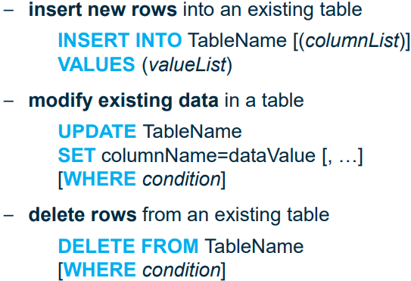
> For insertion, columnList is optional, if not specified the attributes in valueList are added in the order the attributes appear in the table; if it is specified then they will be added in the order specified in columnList. If specified, valueList has to match columnList. Omitted columns are defaulted to null.
> For updating, WHERE is optional. If no WHERE specified, it will update all rows in the table.
> If no WHERE specified for DELETE, then all rows will be deleted – does not delete the table itself.
Data Definition Language (DDL):
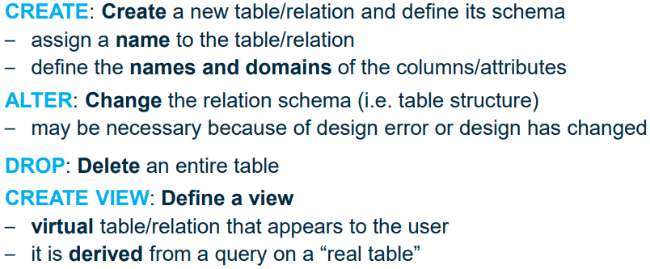
Commands for defining data in the database.
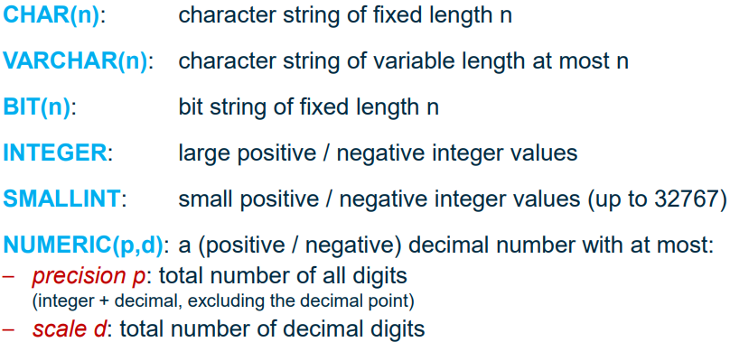
Attribute data types:
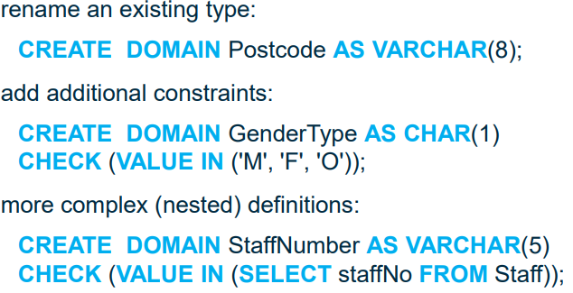
Custom domain types (datatypes) can be created using CREATE DOMAIN command:
Integrity and referential constraints:
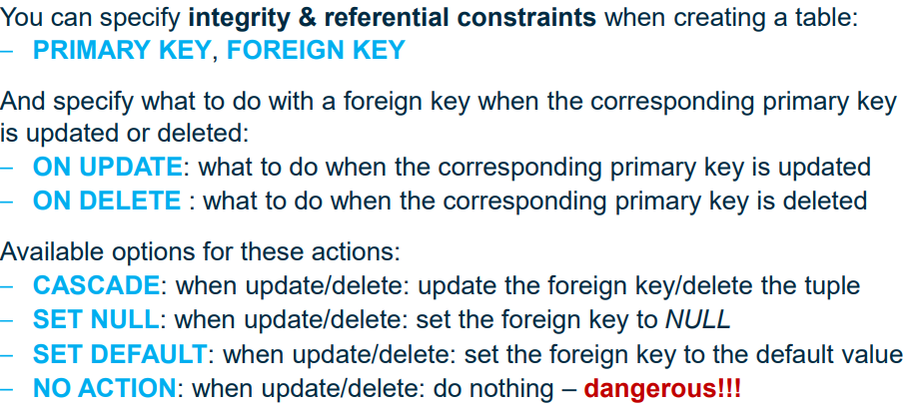
set attributes as primary/foreign keys, and set what happens to foreign keys when the referenced primary key is updated or deleted.

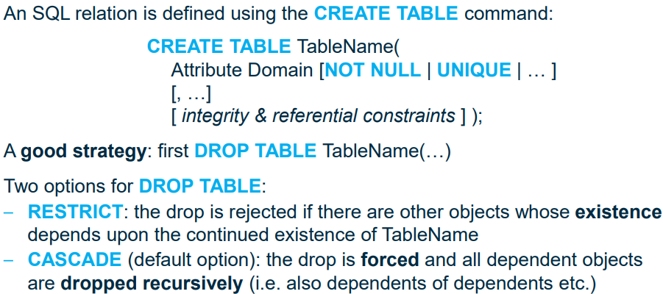
Create table:
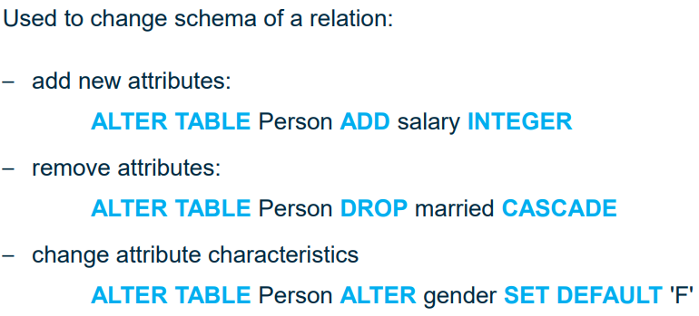
Alter table:
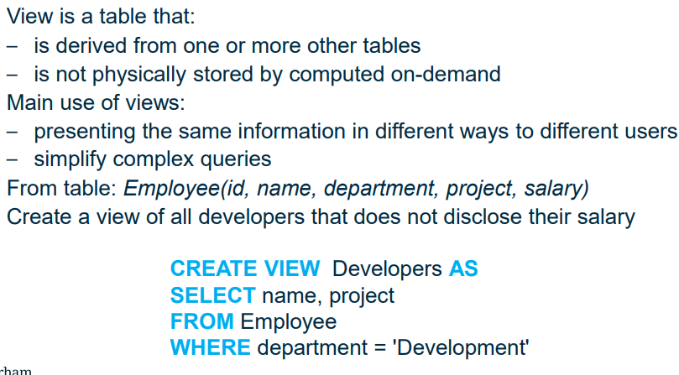
Defining views:
Views can be queried as with other tables. Queries on views are translated as queries on the original table then converted back. This means that view queries are slower.
Not all views can be updated – a view has to contain a candidate key attribute (usually the primary key) for rows to be updates, inserted or deleted, as there needs to be a unique identifier for each row in order to perform these operations.

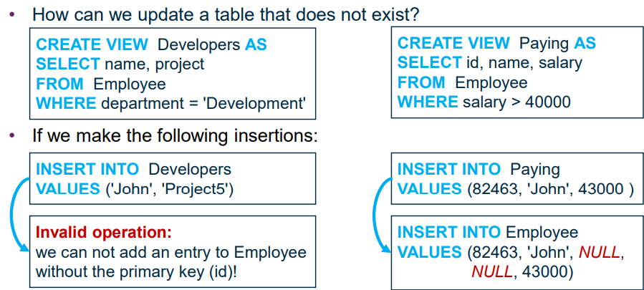
Relational Calculus and Relational Algebra (oh no)
SQL is a declarative language. Declarative queries are converted into procedural form internally. There are different possible transformations which can be used to optimise performance.
Relational Calculus – uses set theory expressions, defines a new set based on existing ones.
Relational algebra – Uses operators to construct a set from existing ones.
Relational calculus and algebra are equivalent languages – for every calculus operation there is one or more algebraic expressions. They are not user friendly
Most modern query languages e.g. SQL are relationally complete (can do anything relational algebra/calculus does), have additional operations (e.g. order/group by, summing), and is generally not Turing complete (but apparently can be if you use it in a weird way)

Relational Calculus:
Predicate – a function that returns True or False when arguments are given
Proposition – the expression obtained by replacing values for the arguments of a predicate, i.e. an instantiation of a predicate.
E.g.
Let P(x), Q(x) be predicates with argument x
The set of all x such that P(x) and Q(x) are true is given by {x | P(x) ^ Q(x)}
The set of all x such that P(x) is not true is given by {x|~P(x)}

Tuple relational calculus is where the variables’ values are tuples
Domain relational calculus is where variables values are attribute values.

Ǝ – There Exists
∀ - For All
To specify that a tuple t should be in a relation Staff, use “Staff(t)” as a predicate.
e.g. {s.salary|Staff(s) ^ s.salary > 10000}

Relational Algebra:
https://cs186berkeley.net/notes/note6/ might help
Procedural – specifies operations to construct a new set from existing ones
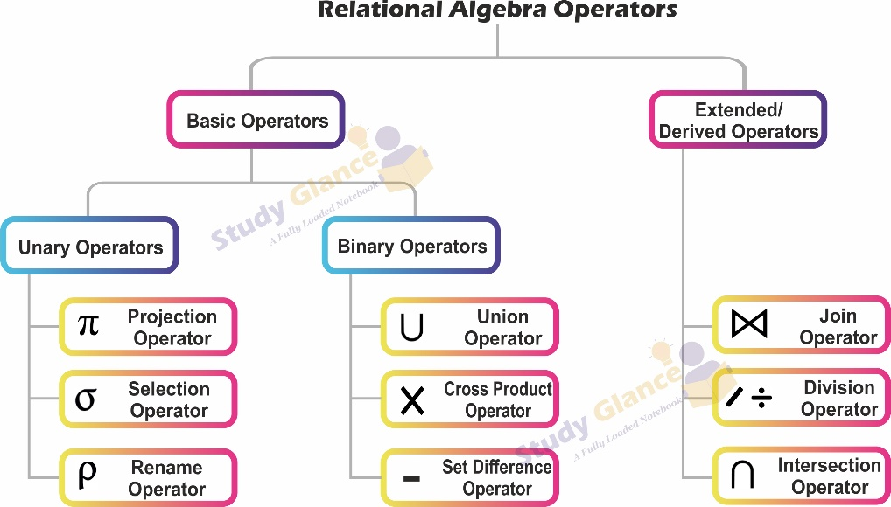
Operations:
Unary:
- Selection
- Projection
- Rename
Binary
- Union
- Set Difference
- Cartesian Product
Derived operations
- Intersection
- Division
- Join

Selection σ:
Unary operation (operates on a single relation R)
- Selects the subset of tuples from R that satisfy the condition (i.e. does the filtering represented by the WHERE clause in SQL)

Projection Π:
Unary operation
- Selects the specified subset of attributes/columns from R
- Eliminates duplicates (as it is set theory)
- Equivalent to a SELECT DISTINCT <columns> in SQL
Union ∪:
- Binary operation – operates on 2 relations A and B
- Selects tuples that are in A or in B
- Result contains tuples from both relations
- Eliminates duplicates
Set Difference -:
- Binary operation
- A-B selects tuples that are in A but not in B
- Removes all tuples from a copy of A that are also in B
Intersection ∩:
- Binary operation
- Selects tuples that are in both A and B
- Derived operation: A ∩ B = A – (A - B)
Compatibility: to perform Union, Difference or Intersection on A and B, need the schemata of A and B to match, i.e. same number of attributes, and matching attributes must have the same domain (attribute names ignored). A and B are then called Union Compatible.
If one relation has additional attributes, use projection to make it union compatible.

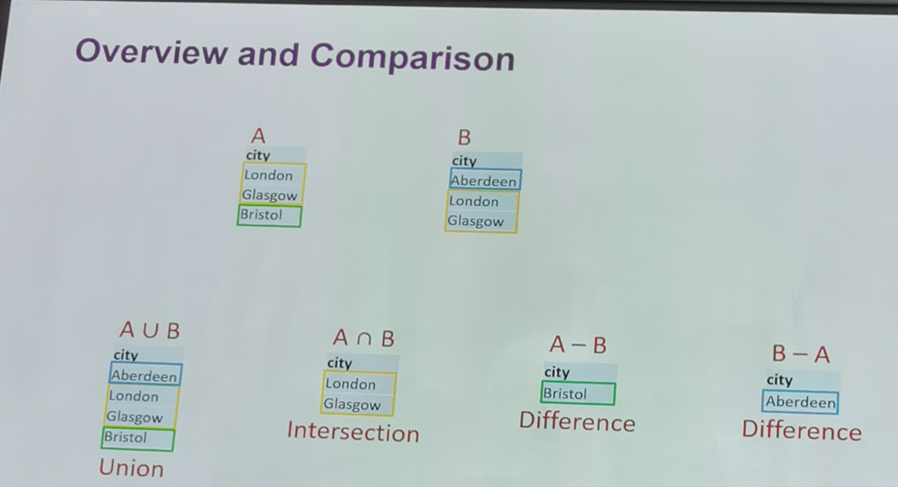
Cartesian Product x:
- Binary operation
- Generates all possible combinations of tuples in A and in B by concatenating them
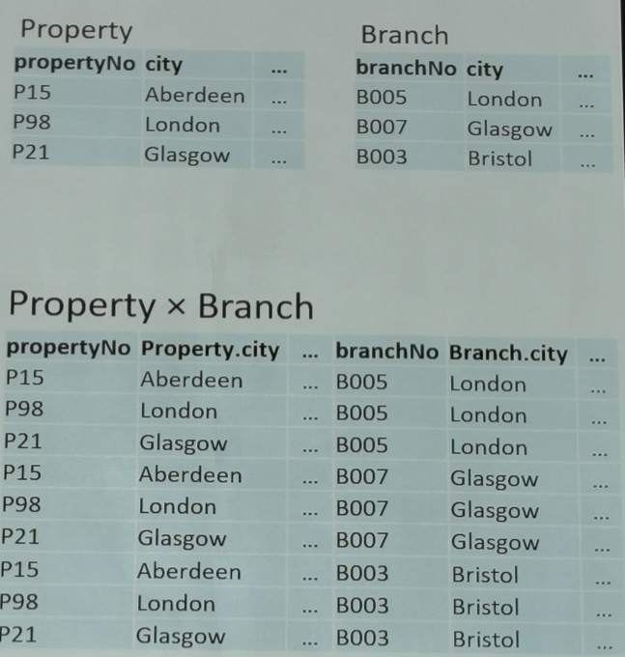
- No compatibility requirements.
- Results in r_{A} * r_{B} tuples with c_{A} + c_{B} attributes where r_{A}, c_{A} represents number of rows in A, number of columns in A
- Attributes with the same name are prefixed with the relation name, e.g. Property.city above.
- This can be used in conjunction with selection and projection to do the various joins (but not efficient).
Rename ρ:
- Unary operation
- Can give names to intermediate expressions in the middle of evaluating an algebraic expression. Ρ_{A}(Family) renames the relation Family as A.
- This is also used when Cartesian producting a table with itself as the two tables need to be given different references.
- Equivalent to aliasing in SQL

Multi-User and Distributed Architectures
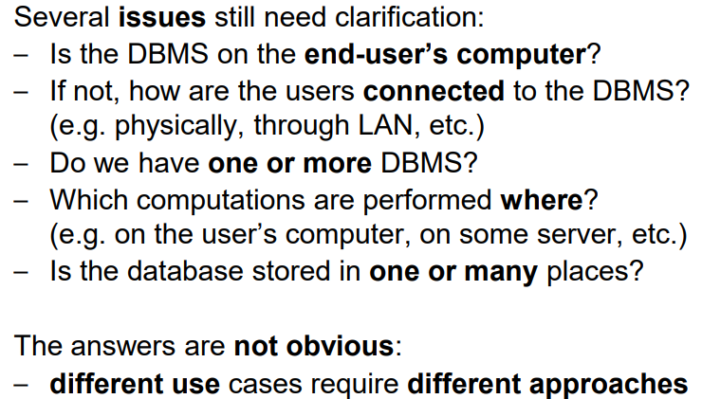
So far, we have had a central database and DBMS, and users can interact with the DBMS using an application. But this does not clarify everything:

Teleprocessing architecture:
The traditional architecture, with one central computer (where all data processing is performed) with many end-user terminals connected to it. Terminals send messages to the central computer, the computer processes the queries and sends the results back to the terminal. The terminal only displays the results – doesn’t do any computations itself.
Issues – burden on the central computer can decrease its performance. The current industry trend is towards downsizing, where expensive powerful mainframe computers are being replaced with many cost-effective less powerful machines for each of the end users to achieve the same or better results.
File-server architecture:
Processing distributed around a network, e.g. a LAN, with a single central file server containing the database. Each workstation has its own DBMS (with different access privileges) and can request files from the file server. The file server acts as a shared hard disk, with no DBMS of its own.
Issues - this approach requires sending a large amount of data across the network, and it can be less secure as sensitive data can be accessed by people who aren’t supposed to see it (even though DBMS restricts access to this data, it is still being sent to the end users, who could potentially find a way of accessing it). A full copy of the tables is required on each workstation and concurrency/integrity control is more difficult to manage, as multiple DBMSs could access the same data simultaneously, as data is modified in a local copy and sent back, and changes could come into conflict.
Client-server architecture:
Two tier:
Client – requires some resource, provides a UI and performs the main data processing.
Server – Provides the resource (DB), performs validations and handles database access.
This allows improved performance as processing is done on the client CPUs in parallel, and there is less data traffic as the server has the DBMS which decides which data is transmitted to each machine – the DB is still centralised.
Issues – hundreds of thousands of users, many different applications. Needs a large server and clients need a lot of processing power to handle the large volumes of data.
Solution: 3-tier architecture.

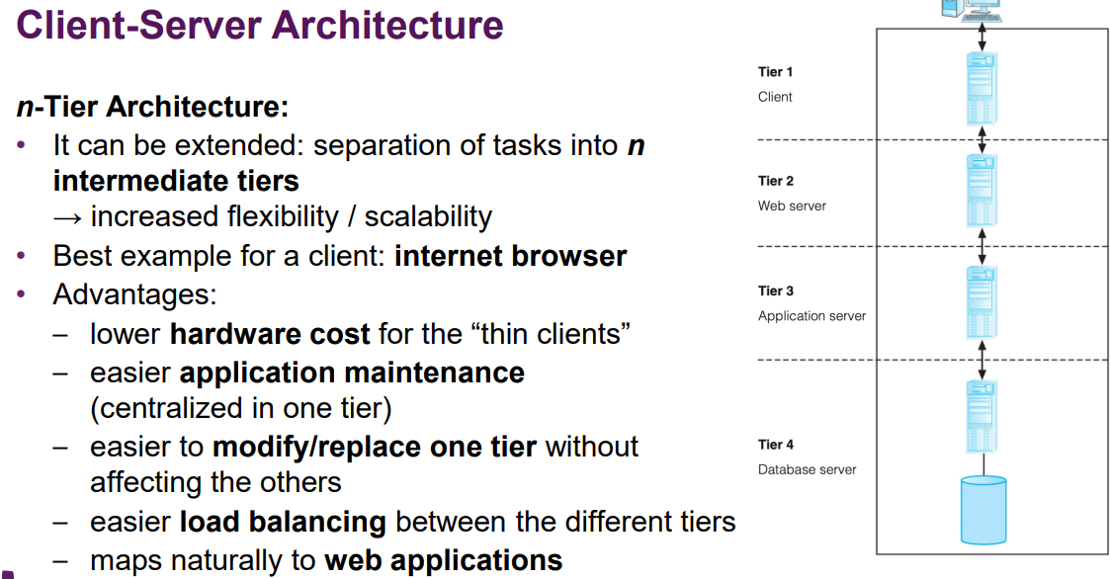
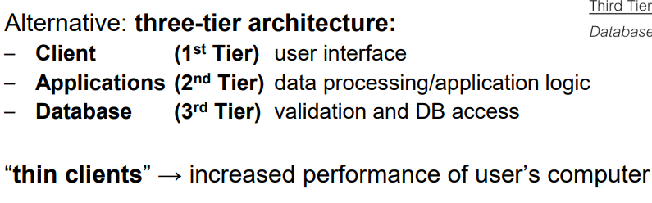
Distributed DBMS:
We can improve database performance with a decentralised approach, using a network of computers to distribute the data, while making all data accessible to all units.
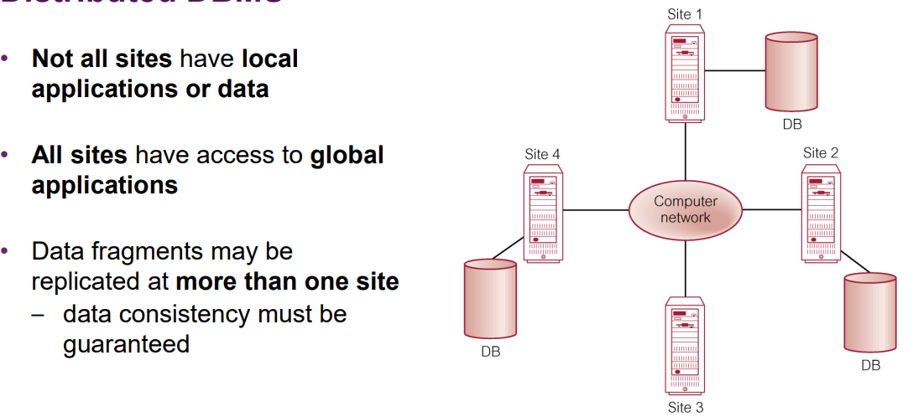
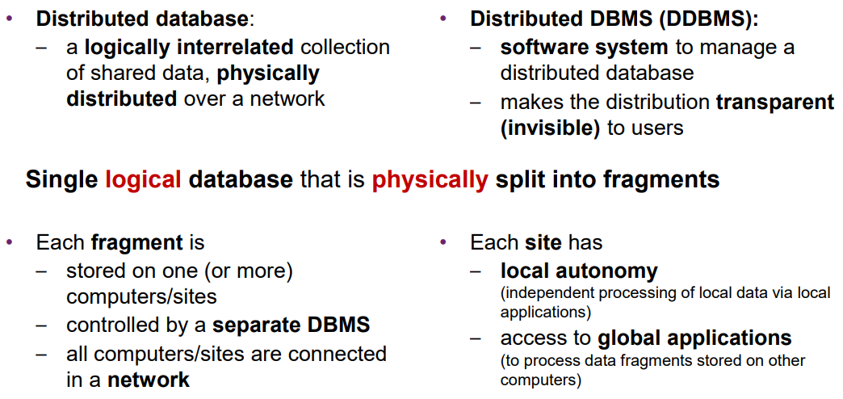
^We want to duplicate data to prevent data loss if one computer on the network dies, but we don’t want to duplicate data if we want to maintain consistency.

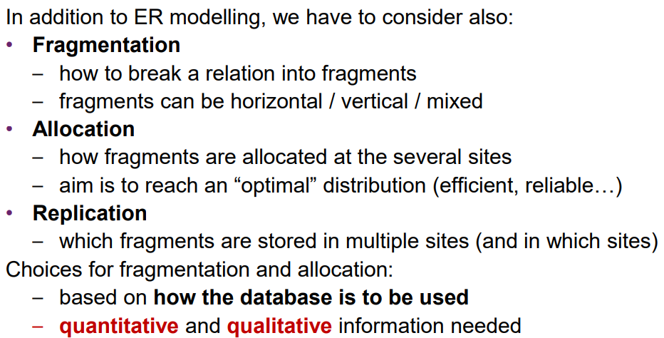
Distributed DBMS design:

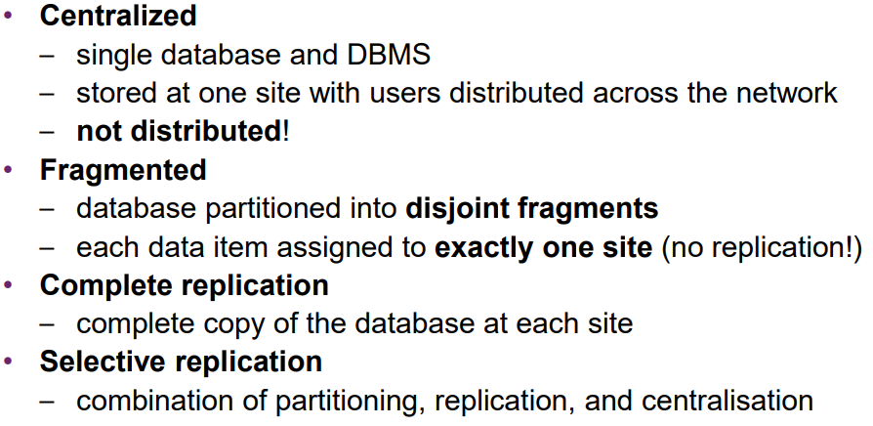
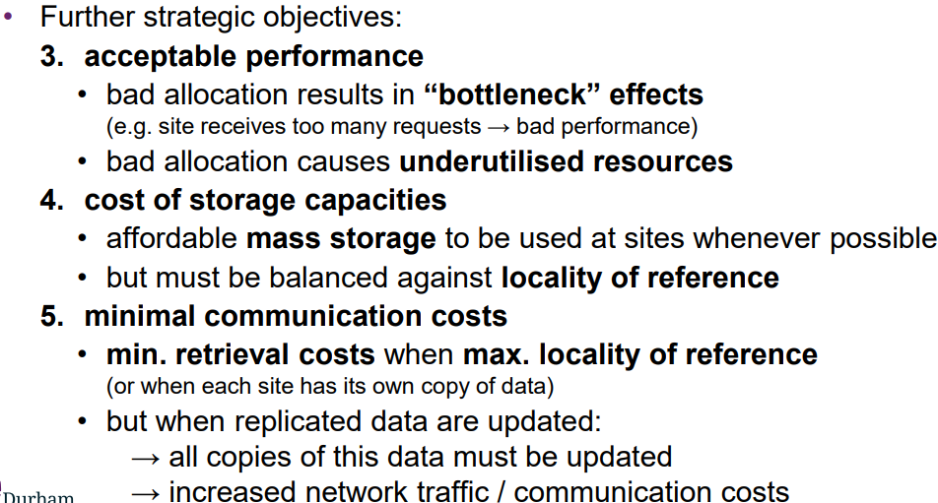
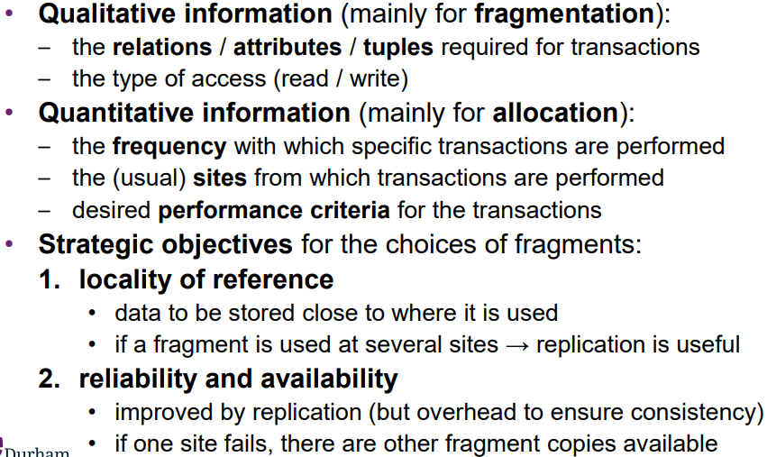
Strategies for the placement of data:

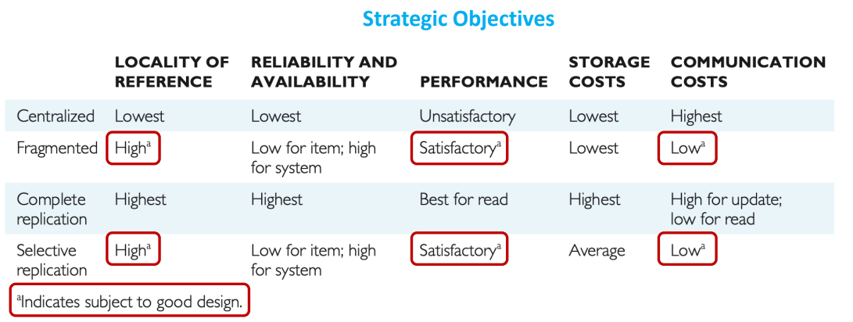
Correctness rules for fragmentation without replication:
- Completeness – if a relation R is decomposed into fragments R₁, …,R_{n} , then each data item must appear in at least one fragment.
- Reconstruction – it must be possible to reconstruct R from its fragments using relational algebra.
- Disjointness – If a data item appears in a fragment R_{i}, then it should not appear in any other fragment, with the exception of the primary key attribute in vertical fragmentation.

Fragmentation types:

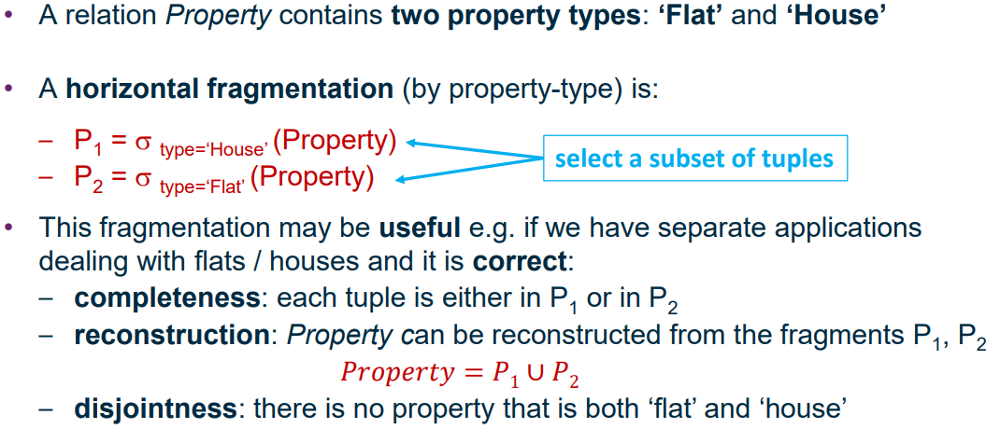
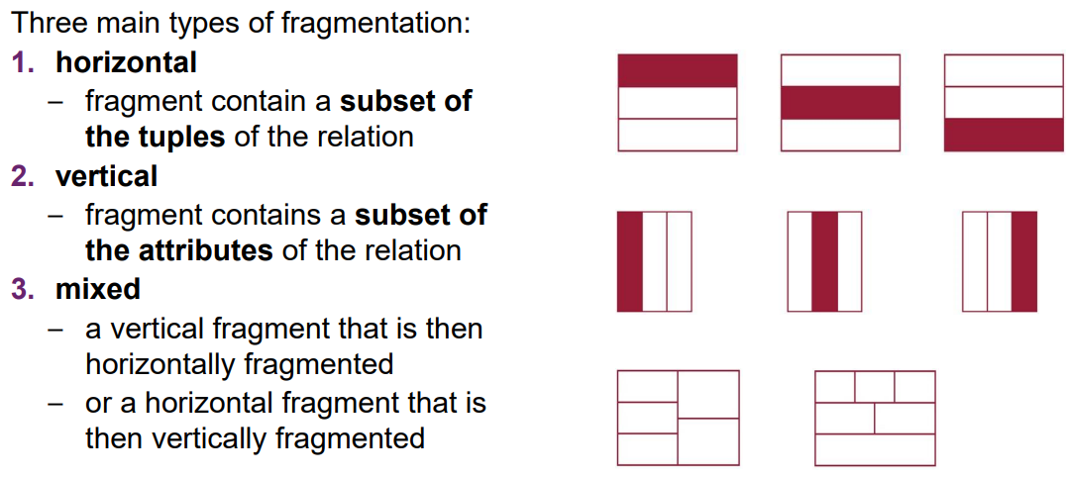
Horizontal fragmentation example:
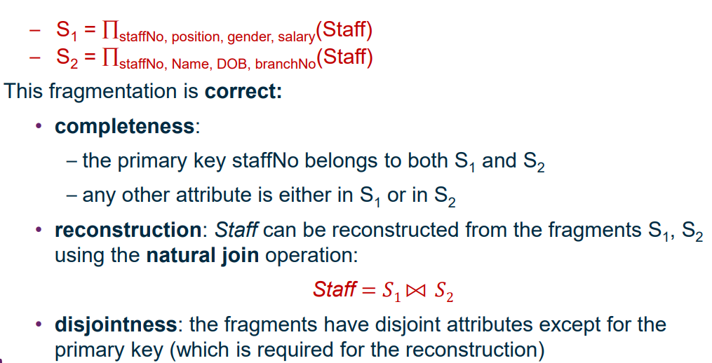
Vertical fragmentation example:

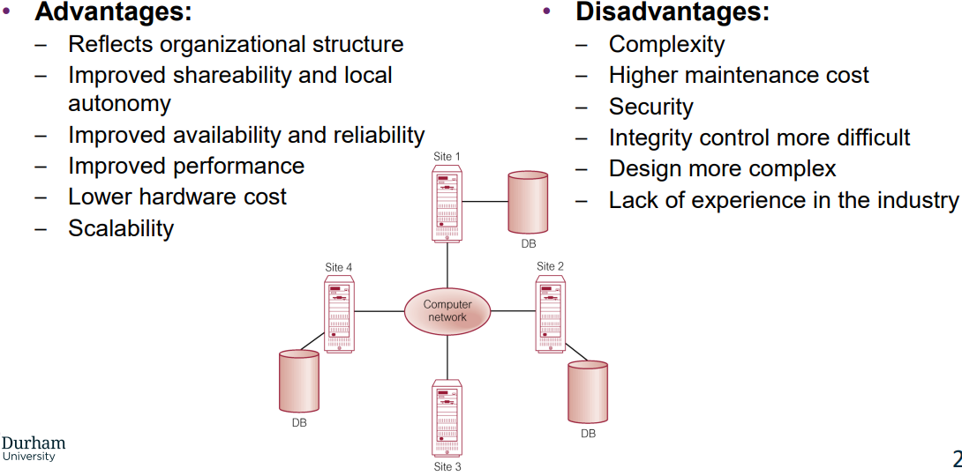
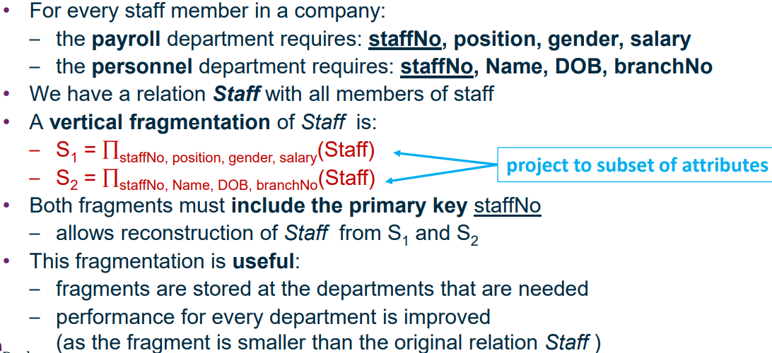
Advantages and Disadvantages of distributed DBMS:

